Creating a society of autonomous agents that have statistical classifiers for brains might make them more than just racist.

Dualae - A Simulated Society of Machine Learning Autonomous Agents
Lucien Rae, 11 July 2017

Abstract

This paper presents the creation of a simulated society made up of grouped autonomous agents that learn how to interact with one another by classifying their experiences with individually trained statistical classifiers.

Keywords: machine learning, statistical classification, autonomous agents, multi-agent systems

1 Introduction

Note: If you’re already familiar with the fundamentals of supervised machine learning, you can skip to Section 1.1 - Initial Concepts.
Machine learning, funnily enough, isn’t magic. It’s mainly maths but I will try and give a brief, top-down explanation of the ideas that go into it, because it is the core concepts of Dualae. Machine learning is a branch of artificial intelligence, it involves giving a computer data that it ‘learns’ the patterns of, and having it use it’s new understanding to predict future data. The part of a program that does this learning is called the ‘classifier.’
Initial data is set out like this: you have a group of ‘features’ that are attached to a ‘label.’ For example: the label ‘apple’ has the features ‘round, fruit.’ This data is called ‘training data’ because it’s used for training (also called fitting). The classifier learns the connections between certain features and certain labels. After it’s done, you are able to give it some features, without a label, and it will it’s best to predict a label. It is a standard for features to be denoted with a capital ‘X’, and labels to be denoted with a lowercase ‘y’. Fitting a classifier aims to turn the training data into a function that applies to all the data:

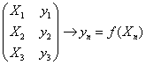

So how does the classifier ‘learn’ the data? Well, there are many many different classifiers that approach the learning in different ways. Neural Networks learn by sending signals through a network of neurons and synapses inspired by the human brain, whereas Decision Tree Classifiers create a branching tree of decisions that can be followed to lead to a conclusion. In supervised learning, all classifiers aim to create a predictor function:

If you want to dig into the details of different classifiers, I highly recommend doing your own research, but I will briefly describe and give visual representations of some in Section 2..

1.1 Initial Concepts

Dualae is a 2D world where autonomous beings with different attributes roam around living their lives. The world moves in steps, and every step, each being decides on which direction it wants to go next. After moving around in different locations and interacting with other beings for a while they build up a database of experiences, which is then used to train a classifier that will serve as its brain. The aim is that the beings will learn their place in the world and how they should interact with one another. Each being is sorted into ‘types’ which dictate their initial attributes. An early concepts can be seen here:

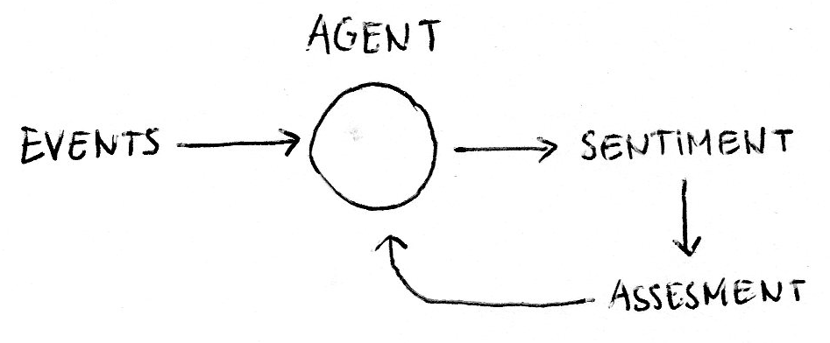
Fig. 1: An early sketch of the logic of an agent’s ‘learning.’

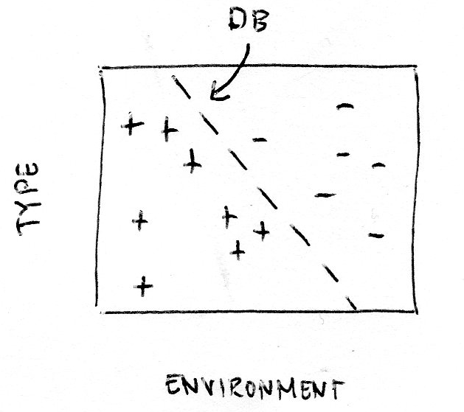
Fig. 2: An early sketch of the visualised ‘brain’ (classifier). Positive and negative data points can be seen. It’s also assumed to be like a Linear SVM (because of the linear hyperplane decision boundary), but that model is unlikely.

1.2 Technical Decisions

I will be using Python 3.5, with the use of the following modules: numpy, scikit-learn, matplotlib, pickle and more. Python is the most widely used language for machine learning, and it is widely considered to be great for the job.
It might surprise you to hear that we will not be using reinforcement learning, but rather, supervised learning. Simply put, reinforcement learning in this kind of scenario has been done a million times before, and I want to try and create a system that can be trained quickly and analyses deeply with cool charts and all that jazz. Scikit-learn also provides great tools for supervised learning. The specific classifier that will be used is described in the next section.

2 Deciding on a Classifier

Firstly, the requirements of our classifier must be decided. It must be able to handle nonlinear data and handle non-binary classes or produce probabilities. One of the biggest concerns is optimization and speed - due to the quantity of classification - so training time is very important. High accuracy is also important, but not crucial. There are many many different types of classifiers but I decided on 5 common ones that I have had experience with:
- K Nearest Neighbors
- Linear Support Vector Machine
- Radial Basis Function Support Vector Machine
- Neural Network (Multi-Layer Perceptrons)
- Decision Tree

All are accessible using scikit-learn. The following tests go off these parameters:

K Nearest Neighbors:
KNeighborsClassifier(3)

Linear SVM:
SVC(kernel=”linear”, C=0.025)

RBF SVM:
SVC(gamma=2, C=1)

Neural Network:
MLPClassifier(alpha=1)

Decision Tree:
DecisionTreeClassifier(max_depth=5)
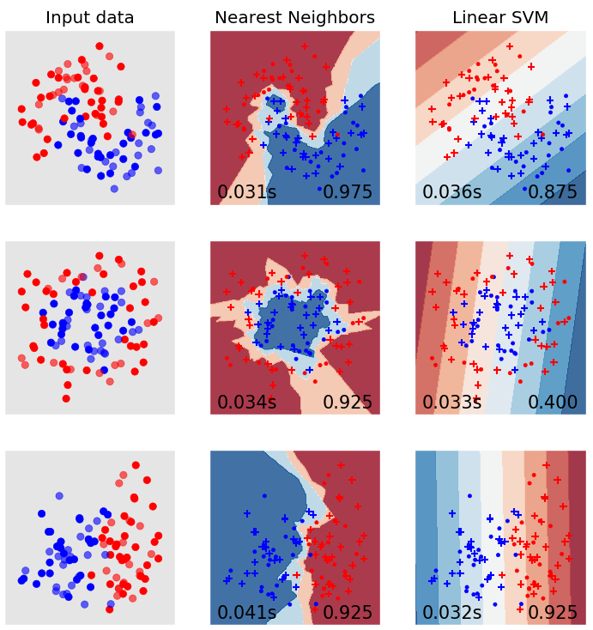

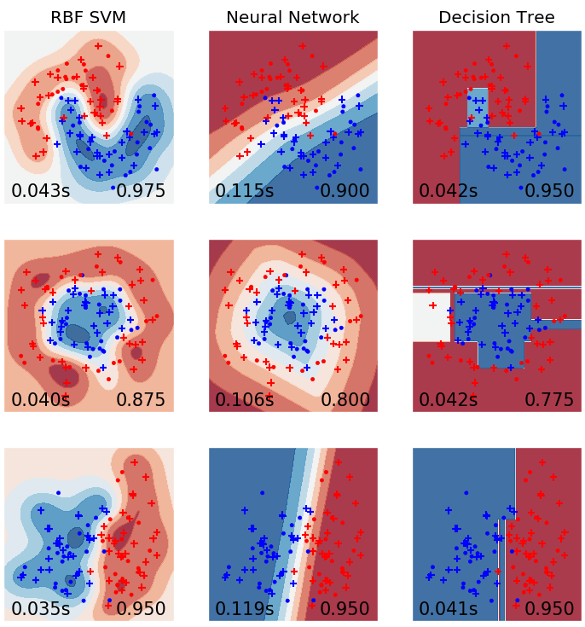
Fig. 3: Visualizations of the different classifiers. Bottom left number is the training time, and bottom right is the accuracy.

The visualizations in Fig. 1. are great, and give us a lot of information for our decision. If you don’t understand what these colors and dots mean, I’ll sum it up: the ‘Input Data’ has been put into a selection of different classifiers. The features are their coordinates on the vector space, and their label is simply an enumeration of their color - red or blue. In the charts, the data has been put in but with the addition of how the classifier has understood the vector space. So, pretty much, the red parts are where the classifier has decided red dots normally go, and blue parts are where the classifier has decided blue dots normally go. How well it did with these decisions can be quickly summed up with how many of the colored dots are in the spots that the classifier thinks they should be. The gradient shows its confidence.
I really like this type of visualization, when it’s with 2-feature data, because it can tell you a lot about the different attributes of the classifier used instead of just looking at the accuracy score alone. I will give a brief analysis of the classifiers here, but if you already understand them all (or just don’t care) then feel free to skip to Section 2.1.
Nearest Neighbors (KNN) - Like the name suggests, nearest neighbors classifies data by examining the proximity to other data points. It doesn’t go great in datasets where everything’s very muddled up, but in the toy set here it goes great. Especially in the second one, the toughest one, it went great because of the strong relationship between neighbors. It also has pretty good training time and consistently impressive accuracy. Well done KNN!
Linear SVM - Now I didn’t have high hopes for this one, but it tried it’s best. It did alright with the first and third dataset but the second really showcased an expected flaw - that a Linear SVM doesn’t do well with non-linear data. It went so badly that it went worse than complete random, concluding that a Linear SVM just won’t be good for the job. They’re normally used for regression so I could have just assumed it wouldn’t have gone great, but oh well, thanks for trying.
RBF SVM (SVM) - Radial Basis Function Support Vector Machine. Wow, say that one five times fast. I’ve decided to just simplify it to ‘SVM’. It did really great, especially in the first dataset, but what surprised me the most was its training time. I had always assumed that a Linear SVM would be radically faster than an RBF but this classifier was only 0.05 seconds slower. It shows great potential for organically-shaped data.
Neural Network (MLP) - Neural Networks are all the rage currently, with Google and many others doing some pretty cool things with them. But their strength is with massive datasets - especially with computer vision. They went pretty good in the testing, but must be condemned for their radically longer training time: almost 3 times longer than the next worst. As mentioned at the start of Section 2, optimization and speed is very important, so I don’t think Neural Networks are the way to go. Don’t worry buddy, you’re great for heaps of other things.
Decision Tree - Now this one went a lot better than I expected. Decision trees are often thought of as a rudimentary introduction to machine learning, but only relevant for very small data sets. Despite this, it performed quite well, with a training time only a bit longer than the rest, and a score that beat even the Neural Network. But, it didn’t beat the Nearest Neighbors or SVM, and I can only imagine how quickly training time increases with more data. So, sorry old friend, you’re still pretty cool. (Side note: I like how you can get an idea of the radical decision boundaries, and always-high confidence of the Decision Tree Classifier just by looking at the visualizations. I like the visualizations.)
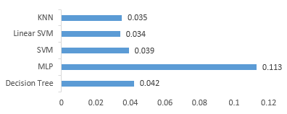
Fig. 4: Average training times of the different classifiers (in seconds).

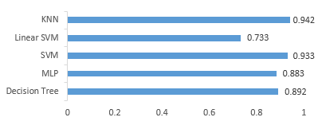
Fig. 5: Average accuracy scores of the different classifiers.

2.1 Choosing a Classifier

Looking at the results in Fig. 4. and Fig. 5., we can see that our two best competitors - Nearest Neighbors and SVM - are very evenly matched. With only 0.04s difference in average training time, and only 0.09 difference in average accuracy score - it’s very hard to decide. So, I dug deeper into the documentation of the classifiers.
The actual libraries for the SVM are written in C and wrapped in Cython, so understanding the nuances of the architecture is difficult, but the LIBSVM paper had some very useful information. Thinking about the future, expanding out of binary classification is a likely move to be made, but SVMs were originally designed for binary classification^{[1]} and solving multi-class problems is still a difficult optimization issue^{[2]}. The Nearest Neighbor Classifier also achieved more consistency, and excelled in the more challenging second dataset (Fig. 3). KNN also has the ability to alter the ‘n_jobs’ parameter, allowing threading to increase optimization. Breaking the tie, I will be using a KNN. This will make any explanations a lot easier (due to the relative simplicity of KNN’s maths) but SVMs are still very impressive so if you’re interested in the model then here’s a link to the paper for LIBSVM: http://www.csie.ntu.edu.tw/~cjlin/papers/libsvm.pdf

There are still elements to test and analyse, for example what the k parameter for KNN will be, but that will be spared for after the whole framework of the system is set up.

3 The ‘Brain’

The ‘brain’ of an agent simply refers to their classifier. I created a class that handles all of this. In use, there is a function to add data, fit (learn) data, and visualize the classifier. All the events that happen (having two features) can be plotted easily. And because we want the sentiment of all those events as the labels, I made the colors from red (negative) to green (positive). It looks likes this:

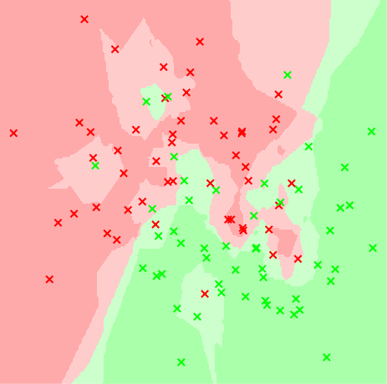
Fig. 6: The visualization of the ‘brain’. The points are all training data, and the contour mapping is the classifiers decision boundaries. In this classifier; k=3.

I made sure to allow the fitting of new training data to be easily done, so that new data can be simply added to the old, ready to be fitted. This ‘brain’ visualization will likely become a series of 3D contour graphs with projected slices – but first the exact features used must be decided. And even before that I should explain what the ‘k’ parameter is.

3.1 The ‘K’ Parameter

The classifier we are using is called K Nearest Neighbors. The ‘Nearest Neighbors’ makes sense because the classifier is about the proximity of other points – neighbors that are near. Not going deep into the technicalities, the process of choosing the decision boundaries is done in a ‘bid’ for the point. By looking at a certain number of neighbors for each class and getting their distance to the point, and finding out which is, overall, closer. How many points are used? The number ‘K.’ The effect that K essentially changes the extent that anomalies are overlooked. If you observe Fig. 6, you will see a few green points in the red area, and also a red point deep in the green area. These didn’t have enough power to turn the area their color because it was just them on their own, and when k=3, one point isn’t enough because it’s only ever a third of the bidding. But, if you observer Fig. 6 again, you can see a small haven of green around a third from the top left. This was won by the green because there were 2 out of 3 in proximity to the points. So what happens when we change k?

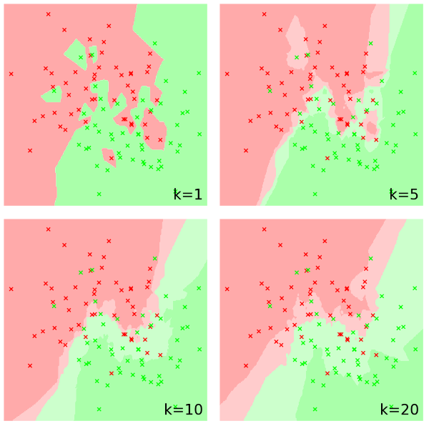

References

[1] C. Cortes and V. Vapnik. Support-vector networks. Machine Learning, 20:273-297 (1995)
http://image.diku.dk/imagecanon/material/cortes_vapnik95.pdf

[2] Chih-Wei Hsu and Chih-Jen Lin. A comparison of Methods for Multi-class Support Vector Machines. National Taiwan University. (2015)
https://www.csie.ntu.edu.tw/~cjlin/papers/multisvm.pdf

